“I can do everything through Him who gives me strength.” -- Philippians 4:13

- Please show all your work! No partial credit will be given for incorrect answers with no work shown. Please draw a box around your final answer.
- Calculators are permitted, but no notes, text, laptops, or PDAs. Cell phones should be muted and left in your pocket or bag. No electronic dictionaries, please.

Simplify (exact answers):
- (8² w⁻⁵) / (4w⁻²)² [2]
4/w
- 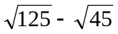 [2]
2 sqrt(5)
- 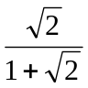 [2]
2 – sqrt(2)
- 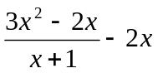 [2]
(x² – 4x) / (x+1)
Factor:
- k² + 5k – 24 [2]
(k – 3) (k + 8)
- g³ – 10g [3]
g (g – sqrt(10)) (g + sqrt(10))
- z² – 2z – 5 [4]
(z – (1+ sqrt(6)) (z – (1 – sqrt(6)))
(quadratic formula)
Solve:
- 3m² – 5m – 2 = 0 [4]
2 or -1/3
- x³ + 5x² + 7x + 3 = 0 [4]
-1 or -3
- x² + 3x = 18 [3]
-6 or +3
- | (x/2) – 3 | < 5 [3]
-4 < x < 16

Word Problems
- Find the centre and radius of the circle x² – 2x + y² + 14y = -14. [4]
Centre (1, -7), radius 6
- A ship is sailing near an island. After t minutes, its distance d from the island in kilometres is given by
d = –3t² + 12t + 30
  - When will the ship reach the island (zero distance)? [4]
2+sqrt(14) =~ 5.74 minutes
  - What is the maximum distance the ship reaches from the island? [4]
42 kilometres
- Start-up costs for your new bookstore are $12,000. Your average costs per sale are $15, and your average revenue per sale is $18.
  - Assuming a linear cost function, what is your cost function? [1]
C = 12,000 + 15x
  - How many sales do you need to make to break even? [3]
4000
- You have three debts that you wish to consolidate: $400 due 4 months ago, $200 due one month ago, and $300 due 5 months from now. How much do you need to repay all three debts now? Assume interest is 20% p.a. compounded monthly. [6]
~$906.88
- Write an expression for the general term t_{n} of each sequence given below.
  - -2, -1/2, 1, 5/2, 4, 11/2, … [2]
t_{n} = -2 + (3/2)(n-1) = -7/2 + (3/2)n
  - 50, 25, 12.5, 6.25, 3.125 … [2]
t_{n} = (50)(1/2)^{n-1} = 100(2)^{-n}
  - 2, 1.5, 4/3, 1.25, 1.2, 7/6, … [2]
t_{n} = (n+1)/n
- Assuming a continuous growth rate of 0.2% per year, how long would it take the world’s population to grow from 2 to 6,000,000? [5]
~7457 years
- Your grandfather gives you $350 cash as a Christmas present. Your mother advises you to invest it in your RRSP, earning interest at 16% p.a. compounded monthly. Instead, you splurge on a new portable MP3 player for $350. The MP3 player depreciates rapidly, losing 40% of its value each year.
  - After two years, the MP3 player is obsolete and you decide to sell it. What is the depreciated value of the MP3 player? [2]
$126
  - If you had listened to your mother, how much would your $350 have grown to in those two years in the RRSP? [4]
~$480.98
  - What was the real total cost of ownership of the MP3 player for those two years? (i.e., how much you sold it for versus how much you would have made if you listened to your mother.) [1]
~$354.98
- The supply and demand functions for a product are given as:
Supply function: P_{s} = 0.15 Q_{s} + 20
Demand function: P_{d} = - 0.6 Q_{d} + 110
Find the equilibrium point. [4]
Q = 120, P = $38
- Consider the series 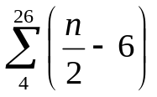.
  - What is the first term of the series? [1]
-4
  - What is the last term of the series? [2]
7
  - What is the sum of the series? [3]
69/2 = 34.5
- Give an exact answer for the sum of the series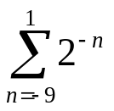. [5]
1023.5

- Your $4,000 portfolio consists of mid-cap equities earning 19% p.a. and treasury bills earning 4% p.a. (both simple interest). After one year, your portfolio grows to a value of $4550. How much is invested in equities and how much in T-bills? [4]

$2600 in equities; $1400 in T-bills
- To buy your house, you obtain a $210,000 mortgage. The loan has 30-year amortization, i.e., you would pay it off in 30 years if you made only the regular payments. The interest rate is 5% p.a., compounded monthly. Equal monthly payments are made at the end of each month. How much is each monthly payment? [8]
~$1127.33

- A company produces two models of car exhausts, model A and model B. To produce each model A requires 20 lbs of steel and 72 min. of labour. To produce each model B requires 25 lbs of steel and 45 min. of labour. A total of 3000 lb of steel and 120 labour hours are available for the production of exhausts each day. [12]
  - Sketch a graph, shading the region representing the allowable number of models A and B the company can produce each day.
20A + 25B ≤ 3000
72A + 45B ≤ 7200
The first line runs through (A=0, B=120) and (A=150, B=0)
The second line runs through (A=0, B=160) and (A=100, B=0)
The corners are (0,0), (A=0, B=120), (A=100, B=0), and (A=50, B=80)
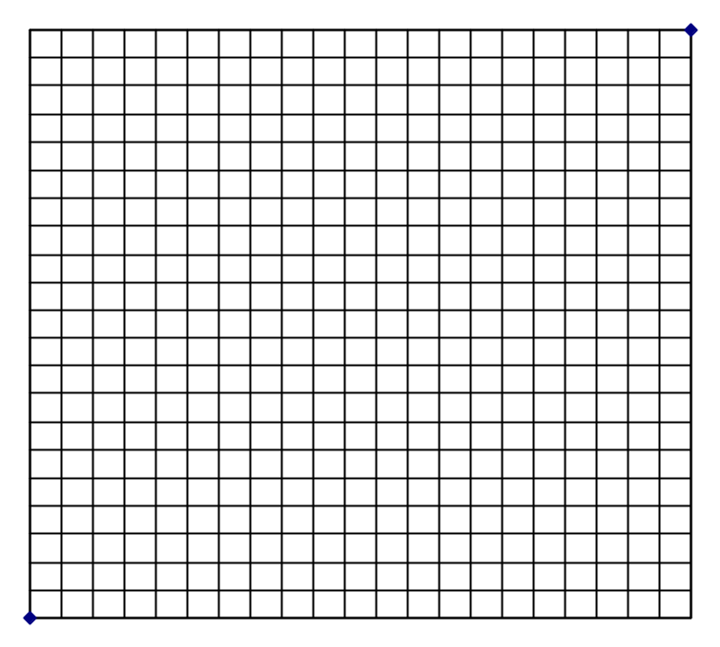
  - The profit for each model A exhaust is $12, and the profit for each model B exhaust is $16. How many exhausts of each model should the company produce each day in order to maximize profit?
Max profit is $1920 at A=0, B=120.

